Name: Title of this Project:

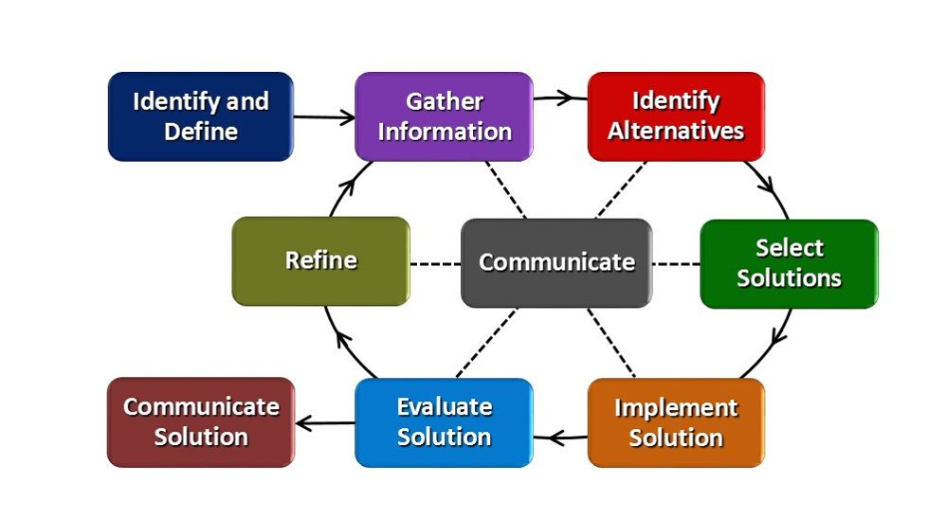

Identify and Define: (Problem Statement) (10 points)
In the text box below, type 1 paragraph (at least 4 correct sentences) that states the problem you are trying to solve.
Identifies the criteria for a successful solution, and defines any constraints. Make a listing of both after the problem statement.
Criteria includes: Measurable standard ie: weight, size, gear ratio… Could be used in a grading rubric.
Constraints is a limitation or condition that must satisfied by the design. Restrictions that keep something from being the best it can be. Problems that arise or issues that come up. Time, Cost, Materials
Statement:

Criteria:

Constraints:

Gather Information: (Research) (50 points 10 for each source)
In the text box below, create an annotated bibliography (at least 5 sources) to gather information for your final design.
Each entry should include a URL (web address) and 1-2 sentences describing how the source could be useful. Include a picture and sentences describing what you learned (if anything) from these sites.
Google images is not a website.
You must go to the site. Copy a picture AND write what you learned. Not learning anything is not acceptable. Something not helpful to your project is acceptable.
Source 1:
URL:
Photo:
1 – 2 sentences about what you learned from this site:

Source 2:
URL:
Photo:
1 – 2 sentences about what you learned from this site:

Source 3:
URL:
Photo:
1 – 2 sentences about what you learned from this site:

Source 4:
URL:
Photo:
1 – 2 sentences about what you learned from this site:

Source 5:
URL:
Photo:
1 – 2 sentences about what you learned from this site:

Identify Possible Solutions: (Brainstorm) (50 points 10 for each solution)
In the text box below, identify at least FIVE ways you might consider as a possible solution. These ideas can be descriptions, pictures, diagrams, or sketches. Any graphics must have accompanying labels and a short summary of the possible solution. You could draw sketches on sketch or graph paper then take pictures of these ideas and add the pictures with descriptions in the box below. Draw sketches dark so they will show up.
Do not make these sketches less than ½ the size of a piece of typing paper. So approximately 8.5” wide by 6.5” tall. Label each drawing with a number or letter. ie: idea #1, #2…
Solution #1:

Solution #2:

Solution #3:

Solution #4:

Solution #5:

Select Solutions: Choose the best idea from above (Refine the idea) (30 points)
In the text box below, identify which alternative (from the previous step) you have chosen to proceed with.
Include 3 sentences explaining WHY you chose that particular solution (be sure to include language from the criteria and constraints).

This step must include a finished drawing, including sizes, and materials you are going to use.

This drawing can be in a CAD program or it can be a detailed drawing using instruments. Sizes must be included in this drawing. This drawing should not be smaller than half scale of the project.

Implement Solution: (Prototype) (50 points)
In the text box below, create a set of “before-during-after” photos and explanations of how you created your solution.
You should have at least 5 photos with captions (1 before, 3-5 during, 1 after). More photos can be used if your project is more complex.

***Take a picture at the end of each day to show your progress.***

Each day you work in class, you need to enter the date and 2 or 3 sentences of what you did in class that day. Be specific. Put down tools used, sizes cut, materials used. This information will be used for your daily grade in class. If you give very little detail, you grade will reflect that.

DETAILS DETAILS DETAILS!!

If you test your project and find it not working and change your idea you must document this in Refine box below.

Date:
What tools, processes, materials did you use?

Evaluate Solution: (test the results) (5 points)
In the text box below, record the results to at least 3 preliminary tests. Test results should include data and speculation as to why those results were achieved. DATA = DETAILS. What worked and what did not work at the end of the project.

Refine: (Iterate your design) (5 points)
When you make a change to your prototype, document those changes here.
In the text box below, write AT LEAST 5 complete, correct sentences that describe:
-how the results from the evaluation can provide information on further improvement of your project
-at least 3 possible ways to make the improvements happen and Why it would help it improve
-how you would have (or will) make the improvement happen
-how you will test to see if the improvement worked or not
-how you predict the improvement will affect the original solution

Communicate: Lastly, at the end of each project you will be required to give a PowerPoint presentation OR Verbal presentation. The presentation outline will follow the Engineering Design Process you just documented. You can use information and photographs from this document to make your presentation.

