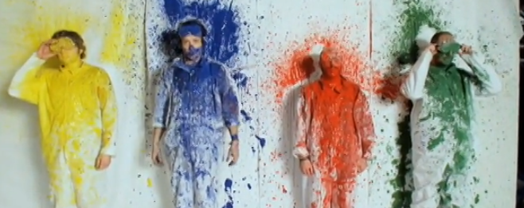
INTRODUCTION:
This is an eleven-minute video about a music video created by an engineering company. The video shows a cool Rube Goldberg machine and lessons learned while taking on this challenge.
LINK: https://www.ted.com/talks/adam_sadowsky_how_to_engineer_a_viral_music_video
Music Video – engineering a music video,
*helpful hint, put close caption on while watching the video
QUESTIONS:
#1. Adam Sadowsky begins this video by stating that this video is about
MUSIC, ____________ and ____________.

#2. The name of the group, in this music video is, OK GO.
What is the name of the song in this video?

#3. How you would explain what a Rube Goldberg machine is?

#4. Why do you think the audience laughed when the speaker shared the 10 Commandments?
Limitations and then added that the band, “wanted all this done ins ‘one shot.’” - (alternatively, in one video shoot; why it is funny for engineers to hear all these parameters and they also hear, ‘do - it in one video take?)

#5. What are some Life Lesson learned?
Small stuff ______________ but is _____________________.
Planning is incredible ___________________________ and so is __________________.
Put reliable stuff ______________.
LIFE CAN BE ________________.
#6. Write a response to two of the choices below.
- What do you think was the most challenging part of the video, why?
- What connections can you make from your learning (in engineering class this year) to this video?
- What connections can you make with this song title, to your world today?
- What Life Lesson mentioned in this video relate to your world? Why or how?

